**UC-01. Child’s development information management for Baan Tantawan.**

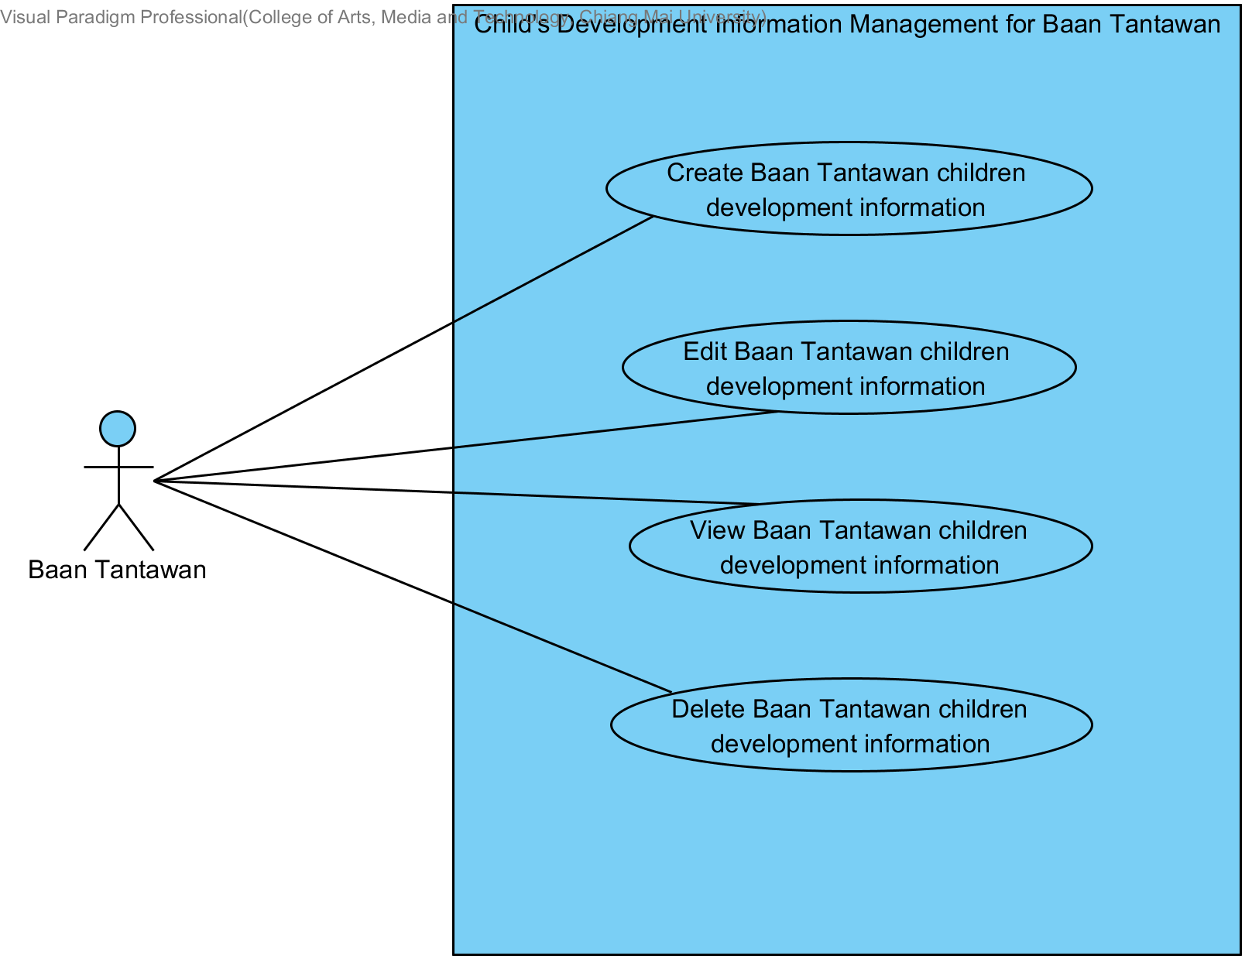

1. **The user can create Baan Tantawan children development information.**
   1. The system shall provide a control button to create new children development information in child development information list.
   2. The system shall provide a user interface that prompt a user for input including evaluation date, children fine and gross motor, children weight, height and head circumference after evaluate, physical development, intellectual development, social and mood development, positive behavior, negative behavior, behavior modification, result of behavior modification, development result, family status and helping plan.
   3. The system shall provide a control button to save the children development information.
   4. The system shall give a notification message “Invalid Date.” When wrong input format of checkup date. The format must be MM/DD/YYYY.
   5. The system shall give a notification message “You must enter a value” when a user does not input the checkup date.
   6. The system shall give a notification message “Invalid Number” when a user input invalid height of children type. Input must be a number only.
   7. The system shall give a notification message “ส่วนสูงต้องมากกว่า 50 เซนติเมตร” when a user input height of children less than 50 centimeters.
   8. The system shall give a notification message “You must enter a value” when a user does not input the height of children.
   9. The system shall give a notification message “Invalid Number” when a user input invalid weight of children type. Input must be number only
   10. The system shall give a notification message “You must enter a value” when a user does not input the weight of children.
   11. The system shall give a notification message “Invalid Number” when a user input invalid head circumference of children type. Input must be a number only.
   12. The system shall save the information to the data storage. When information is saved the system shall give notification message “Child development created” and the system shall redirect page to view children development information (URS-03) page and show the information to the user.

|  |  |  |  |  |
| --- | --- | --- | --- | --- |
| **Use Case ID** | UC-01 | | **URS ID** | URS-01 |
| **Use Case Name** | Create Baan Tantawan child development information. | | | |
| **Create by** | Suradis Sutampang | | **Last Update by** | Suradis Sutampang |
| **Date Created** | 7/7/2017 | | **Last Revision Date** | 7/7/2017 |
| **Actors** | Users | | | |
| **Description** | Users can create child development information in the database including date of evaluating, fine motor, gross motor, weight, height, head circumference, Intellectual development, social development, positive behavior, negative behavior, behavior modification, result of behavior modification, development result, family status, helping plan. | | | |
| **Trigger** | Users click create new children development information button in children development information table. | | | |
| **Precondition** | Have child information in the database. | | | |
| **Post-condition** | None | | | |
| **Input** | | | | |
| **Name** | **Description** | **Constraints** | **Type** | **Example** |
| Date of evaluate | date of evaluating child | Date of evaluation must not be empty | date | 22/07/2017 |
| Fine motor |  |  |  |  |
| Gross Motor |  |  |  |  |
| Weight | child weight in kilogram in the date of evaluation | weight must not be empty | float | 112.5 |
| Height | child height in centimeter in the date of evaluation | height must not be empty and have more than 50 | float | 123 |
| Head circumference | child head circumference in centimeter in the date of evaluation | head circumference must not be empty | float | 40 |
| Physical development | child physical development in the date of evaluation | physical development must not be empty | string | high strength |
| Intellectual development | child intellectual development in the date of evaluation | intellectual development must not be empty | string | normal intellectual |
| Social development | child social development in the date of evaluation | social development must not be empty | string | anti-social |
| Positive behavior |  |  |  |  |
| Negative behavior |  |  |  |  |
| Behavior modification |  |  |  |  |
| Result of behavior modification |  |  |  |  |
| Family status | child family status in the date of evaluation | family status must not be empty | string | normal |
| Helping plan | helping plan for a child in the date of evaluation | - | string | have to take care about his social like trying to talk to him |
| **Normal Flow** | **Actors** | | **System** | |
| 1. Click create new children development information. | |  | |
|  |  | | 2. Provide a user interface that prompt a user for input including evaluation date, children weight, height and head circumference after evaluate, physical development, intellectual development, social and mood development, family status and helping plan. | |
|  | 3. Input data including evaluation date, children weight, height and head circumference after evaluate, physical development, intellectual development, social and mood development, family status and helping plan. | |  | |
|  | 4. click save button. | |  | |
|  |  | | 5. Check validation. | |
|  |  | | 6. Save child development information to the database. | |
|  |  | | 7. Show notification “Child development created.” | |
|  |  | | 8. redirect page to view children development information. | |
| **Alternative Flow** | 1. The system shall give a notification message “Invalid Date.” When wrong input format of checkup date. The format must be MM/DD/YYYY. 2. The system shall give a notification message “You must enter a value” when a user does not input the checkup date. 3. The system shall give a notification message “Invalid Number” when a user input invalid height of children type. Input must be a number only. 4. The system shall give a notification message “ส่วนสูงต้องมากกว่า 50 เซนติเมตร” when a user input height of children less than 50 centimeters. 5. The system shall give a notification message “You must enter a value” when a user does not input the height of children. 6. The system shall give a notification message “Invalid Number” when a user input invalid weight of children type. Input must be number only 7. The system shall give a notification message “You must enter a value” when a user does not input the weight of children. 8. The system shall give a notification message “Invalid Number” when a user input invalid head circumference of children type. Input must be a number only. | | | |
| **Exception Flow** |  | | | |

1. **The user can edit Baan Tantawan children development information.**
   1. The system shall provide a control button to edit the children development information.
   2. The system shall provide a user interface with old data that prompt a user to input new including children weight, height and head circumference after evaluate, children fine and gross motor, intellectual development, positive behavior, negative behavior, behavior modification, result of behavior modification, development result, social and mood development, family status and help plan.
   3. The system shall provide a control button to save the children development information.
   4. The system shall give a notification message “Invalid Number” when a user input invalid height of children type. Input must be a number only.
   5. The system shall give a notification message “ส่วนสูงต้องมากกว่า 50 เซนติเมตร” when a user input height of children less than 50 centimeters.
   6. The system shall give a notification message “You must enter a value” when a user does not input the height of children.
   7. The system shall give a notification message “Invalid Number” when a user input invalid weight of children type. Input must be number only
   8. The system shall give a notification message “You must enter a value” when a user does not input the weight of children.
   9. The system shall give a notification message “Invalid Number” when a user input invalid head circumference of children type. Input must be a number only.
   10. The system shall give a notification message “You must enter a value” when a user does not input the checkup date.
   11. The system shall save the update information to the data storage. When update information is saved the system shall redirect page to view children development information (URS-03) page and show the update information to the user.

|  |  |  |  |  |
| --- | --- | --- | --- | --- |
| **Use Case ID** | UC-01 | | **URS ID** | URS-02 |
| **Use Case Name** | Edit Baan Tantawan child development information. | | | |
| **Create by** | Suradis Sutampang | | **Last Update by** | Suradis Sutampang |
| **Date Created** | 7/7/2017 | | **Last Revision Date** | 7/7/2017 |
| **Actors** | Users | | | |
| **Description** | Users can edit child development information in the database including fine motor, gross motor, weight, height, head circumference, positive behavior, negative behavior, behavior modification, the result of behavior modification, development result, Intellectual development, social development, family status, helping plan. | | | |
| **Trigger** | Users click Edit button in children development information details. | | | |
| **Precondition** | Have child information in the database. | | | |
| **Post-condition** | None | | | |
| **Input** | | | | |
| **Name** | **Description** | **Constraints** | **Type** | **Example** |
| weight | child weight in kilogram in the date of evaluation | weight must not be empty | float | 112.5 |
| height | child height in centimeter in the date of evaluation | height must not be empty and have more than 50 | float | 23 |
| head circumference | child head circumference in centimeter in the date of evaluation | head circumference must not be empty | float | 40 |
| physical development | child physical development in the date of evaluation | physical development must not be empty | string | high strength |
| Intellectual development | child intellectual development in the date of evaluation | intellectual development must not be empty | string | normal intellectual |
| social development | child social development in the date of evaluation | social development must not be empty | string | anti-social |
| family status | child family status in the date of evaluation | family status must not be empty | string | normal |
| helping plan | helping plan for a child in the date of evaluation | - | string | have to take care about his social like trying to talk to him |
| **Normal Flow** | **Actors** | | **System** | |
| 1. Click Edit button. | |  | |
|  |  | | 2.Retrieve child development information in the database. | |
|  |  | | 3. Provide a user interface that prompt a user to edit including children weight, height, and head circumference after evaluate, physical development, intellectual development, social and mood development, family status and helping plan. | |
|  | 4. Edit data including children weight, height, and head circumference after evaluate, physical development, intellectual development, social and mood development, family status and helping plan. | |  | |
|  | 5. click save button. | |  | |
|  |  | | 6. Check validation. | |
|  |  | | 7. Update child development information to the database. | |
|  |  | | 8. Show notification “Child development Updated.” | |
|  |  | | 9. redirect page to view children development information. | |
| **Alternative Flow** | 1. The system shall give a notification message “Invalid Number” when a user input invalid height of children type. Input must be a number only. 2. The system shall give a notification message “ส่วนสูงต้องมากกว่า 50 เซนติเมตร” when a user input height of children less than 50 centimeters. 3. The system shall give a notification message “You must enter a value” when a user does not input the height of children. 4. The system shall give a notification message “Invalid Number” when a user input invalid weight of children type. Input must be number only 5. The system shall give a notification message “You must enter a value” when a user does not input the weight of children. 6. The system shall give a notification message “Invalid Number” when a user input invalid head circumference of children type. Input must be a number only. | | | |
| **Exception Flow** |  | | | |

1. **The user can view Baan Tantawan children development information.**
   1. The system shall provide children development information table as a related list in Health in FFC page including children development record, children name, the date that children have joined Foundation, children age while joined Foundation, evaluation date, current age. When the user clicks on children development record, the system will redirect to children development information detail page.
   2. The system shall provide a user interface that show a children development information details to a user including children name, children birthday, children birth weight, current children age, date that children are joined Foundation, children age before joined Foundation, children weight, height and head circumference while joined Foundation, evaluation date, children weight, height and head circumference after evaluate, physical development, intellectual development, social and mood development, family status and help plan.

|  |  |  |  |  |
| --- | --- | --- | --- | --- |
| **Use Case ID** | UC-01 | | **URS ID** | URS-03 |
| **Use Case Name** | View Baan Tantawan child development information. | | | |
| **Create by** | Suradis Sutampang | | **Last Update by** | Suradis Sutampang |
| **Date Created** | 7/7/2017 | | **Last Revision Date** | 7/7/2017 |
| **Actors** | Users | | | |
| **Description** | Users can view child development information in database including children name, children birthday, children birth weight, current children age, date that children are joined Foundation, children age before joined Foundation, children fine and gross motor, children weight, height and head circumference while joined Foundation, evaluation date, children weight, height and head circumference after evaluate, intellectual development, social and mood development, positive behavior, negative behavior, behavior modification, result of behavior modification, family status and help plan. | | | |
| **Trigger** | Users click Child Development button. | | | |
| **Precondition** | Have child information in the database. | | | |
| **Post-condition** | None | | | |
| **Input** | | | | |
| **Name** | **Description** | **Constraints** | **Type** | **Example** |
| - | - | - | - | - |
| **Normal Flow** | **Actors** | | **System** | |
| 1. Click Child development button. | |  | |
|  |  | | 2.Retrieve child development list in the database. | |
|  |  | | 3. provide children development information table as a related list in Health in FFC page including children development record, children name, the date that children have joined Foundation, children age while joined Foundation, evaluation date, current age. | |
|  | 4. click development record. | |  | |
|  |  | | 5.Retrieve child development in the database. | |
|  |  | | 6. provide a user interface that show a children development information details to a user including children name, children birthday, children birth weight, current children age, date that children are joined Foundation, children age before joined Foundation, children weight, height and head circumference while joined Foundation, evaluation date, children fine and gross motor, children weight, height and head circumference after evaluate, intellectual development, social and mood development, positive behavior, negative behavior, behavior modification, result of behavior modification, family status and help plan. | |
| **Alternative Flow** |  | | | |
| **Exception Flow** |  | | | |

1. **The user can delete Baan Tantawan children development information.**
   1. The system shall provide a control button to delete the children development information.
   2. The system shall provide a popup to give a notification message “Are you sure?” and confirm button after a user click on delete button.
   3. The children development information is deleted. The children development information must disappear from the user interface.

|  |  |  |  |  |
| --- | --- | --- | --- | --- |
| **Use Case ID** | UC-01 | | **URS ID** | URS-03 |
| **Use Case Name** | Edit Baan Tantawan child development information. | | | |
| **Create by** | Suradis Sutampang | | **Last Update by** | Suradis Sutampang |
| **Date Created** | 7/7/2017 | | **Last Revision Date** | 7/7/2017 |
| **Actors** | Users | | | |
| **Description** | Users can delete child development information in the database. | | | |
| **Trigger** | Users click delete button in children development information details. | | | |
| **Precondition** | Have child information in the database. | | | |
| **Post-condition** | None | | | |
| **Input** | | | | |
| **Name** | **Description** | **Constraints** | **Type** | **Example** |
| - | - | - | - | - |
| **Normal Flow** | **Actors** | | **System** | |
| 1. Click delete button. | |  | |
|  |  | | 2. Provide a popup to give a notification message “Are you sure?” and confirm button. | |
|  | 3. Click confirm button. | |  | |
|  |  | | 4. Delete child development information in database. | |
|  |  | | 5. Show notification “Child development deleted.” | |
|  |  | | 6. Redirect to child development list. | |
| **Alternative Flow** |  | | | |
| **Exception Flow** |  | | | |